PROJECT CLASS

WHY DO WE NEED TO THE PROJECT CLASS?

TO FULL FILL THE YEAR GAP WITH KIND OF REAL TIME EXPERINECT

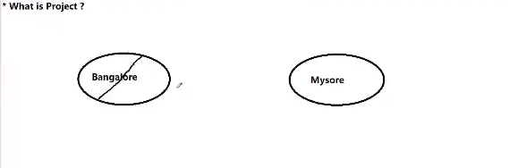

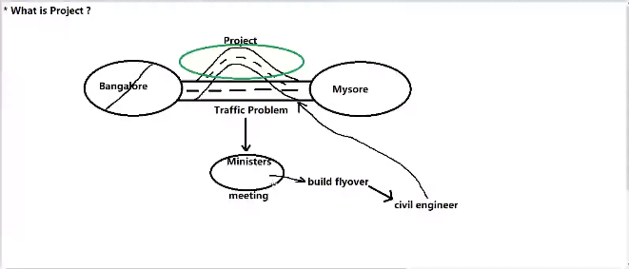

WHO CAN BE THE CUSTOMER OR CLIENT

ANY BUSINESSMAN WHO WANT TO RUN THEIR BUSINESS THROUGH SOFTWARE OR ONE WHO WANT TO AUTOMATE THEIR BUSINESS

CUSTOMER GIVING REQUIREMENTS , WHAT KIND OF PROBLEM HE IS FACING IN THE BUSINESS ,

SOFTWARE COMPANY DEVLOPS SW AS SOLUTION TO THE CUSTOMERS PROBLEM WHAT CUSTOMER WAS FACING

TO RESOLVE CUSTOMER PROBLEM

KIND OF SOLUTION

IS A PROJECT

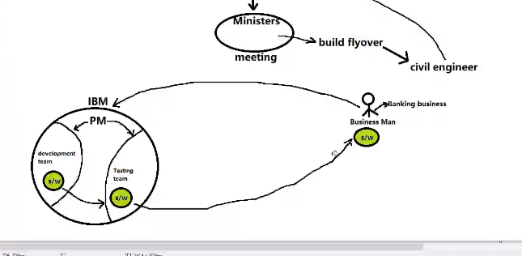

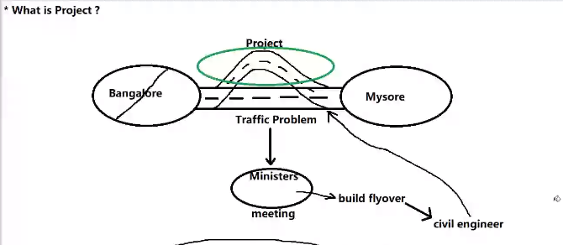

**WHAT IS PROJECT**

**DEVLOPING A SOLUTION IN ORDER TO RESOLVE CUSTOMERS PROBLEM.**

**OR**

**IN ORDER TO SATISFY THE CUSTOMER NEEDS.**

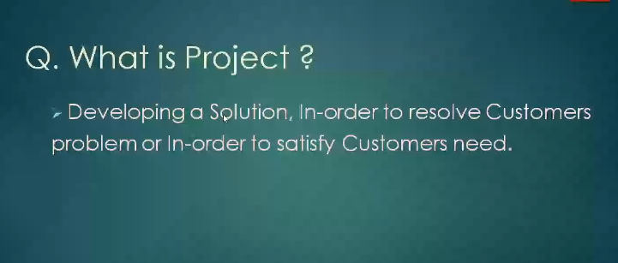

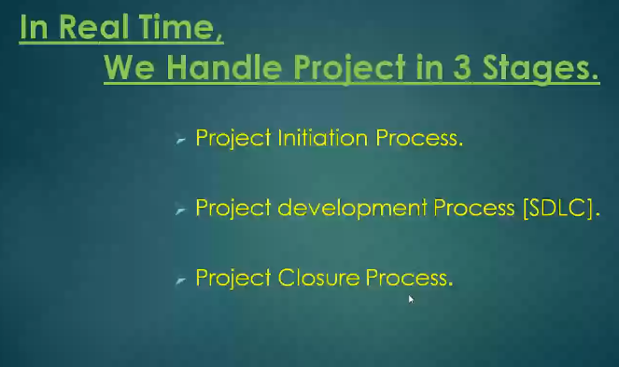

**PROJECT INITIATION PROCESS:**

1. **REQUIREMENT COLLECTION**
2. **FEASIBLITY STUDY**

**PROJECT DEVELOPMENT PROCESS [SDLC]**

1. **DESIGN**
2. **CODING**
3. **TESTING**

**PROJECT CLOSURE MEETING**

1. **RETROSPECT MEETING**
2. **RELEASE NOTE**
3. **TEST EXECUTION REPORT**
4. **DEFECT REPORT**
5. **GRAPHS**
6. **METRICES**

**PROJECT INITIATION PROCESS**

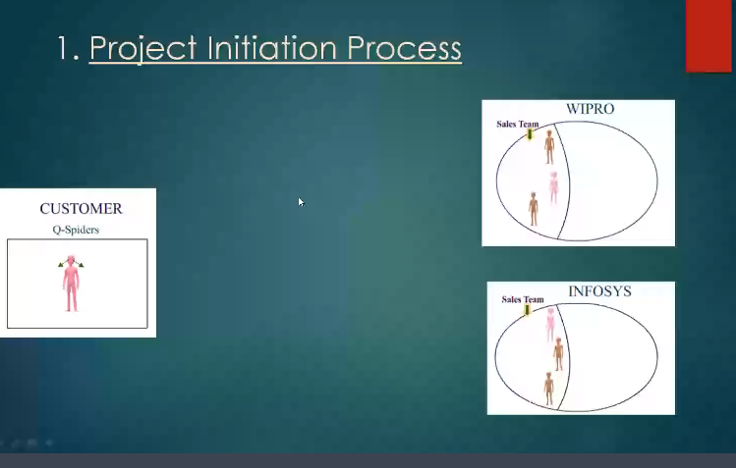

**PS STANDS FOR PROBLEM STATEMENT**

**NA STANDS FOR NEED ANALYSIS**

**HE(QSPIDER) WILL SEND THE REQUIREMENT TO MULTIPLE SW COMPANY**

**WHY MULTIPLE COMPANY?**

**IF THE SALES TEAM COME TO KNOW THEY CAN DEVELOP A SW TO THE CUSTOMER AFTER UNDERSTANDING THE PS, THEN SALES TEAM WILL CREATE A PROPOSAL , ELSE THEY WILL REJECT THE PS IN THE BEGNING ITSELF.**

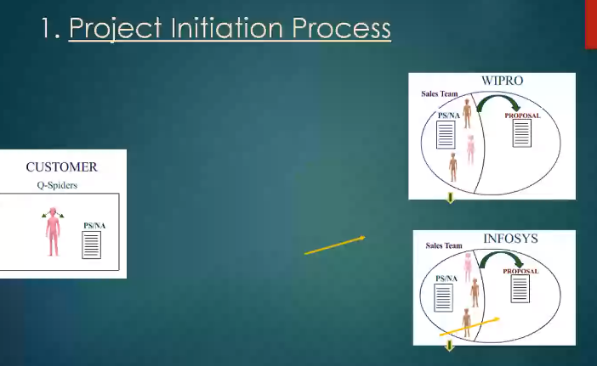

**PROPOSAL**

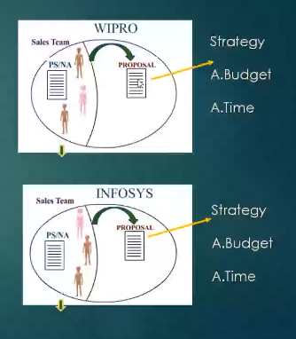

**PROPOSAL CONTAINS THE STRATERGY , BUDGET AND TIME .**

**IF CUSTOMER RECEIVED TWO PROPOSAL**

**FIRST PRIORITY GOES TO STRATERGY, BECAUSE IF THE STRATERGY IS GOOD, QUALITY WILL BE GOOD.**

**BUDGET AND TIME CAN BE BARGAINED , BOTH ARE READY TO COMPARMISE**

**IN THIS EXAMPLE CUSTOMER LIKE WIPRO STRATERGY**

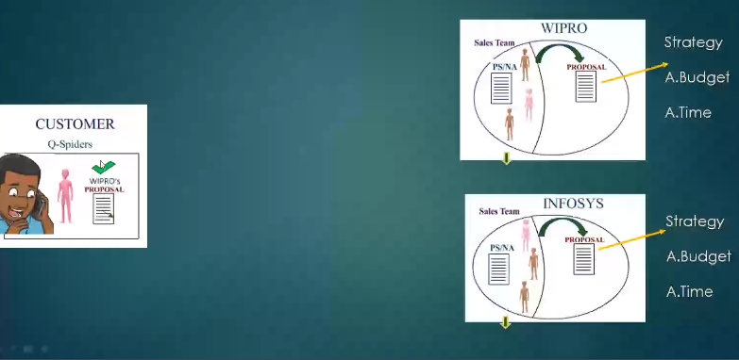

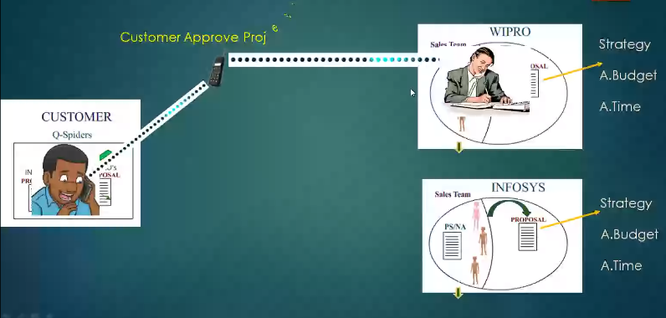

**IT INDICATES BOTH OF THEM AGREED .**

**ONCE CUSTOMER AND COMPANY IS AGREE. THEN SW COMPANY PREPARE A DOCUMENT THAT IS MOU/MSA.**

**TERMS AND CONDITION**

**AND**

**WHAT KIND OF SERVICES COMPANY ID GOING TO PROVIDE**

**SLA- SERVICE LEVEL AGREEMENT**

**CUSTOMER WILL FIRST SIGN THE DOCUMENT**

**PROJECT INITIATION PROCESS OVER.**

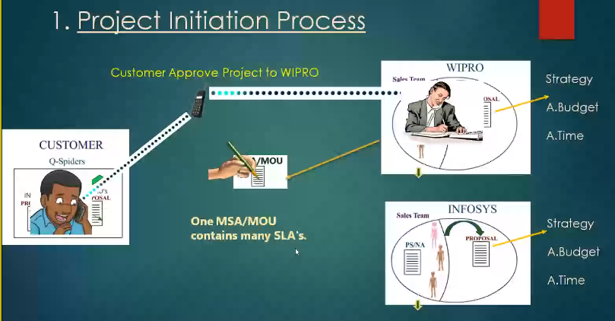

**5-7 MIN TIME TO NOTE ALL THE THINGS THAT HAS BEEN TAUGHT.**

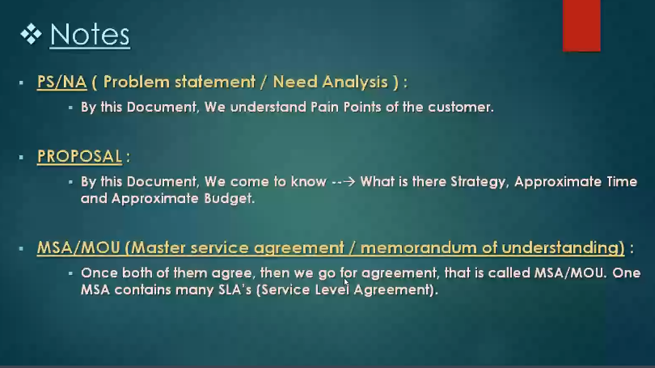

**PROJECT DEVELOPMENT PROCESS**

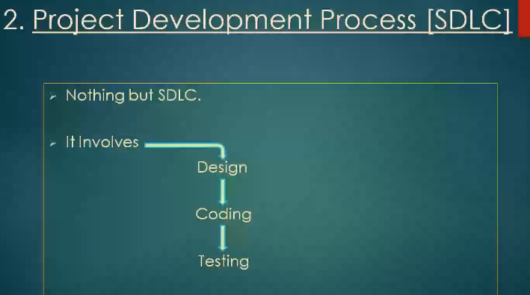

**PROJECT CLOSURE PROCESS**

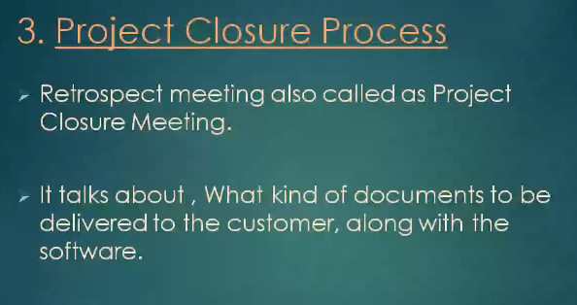

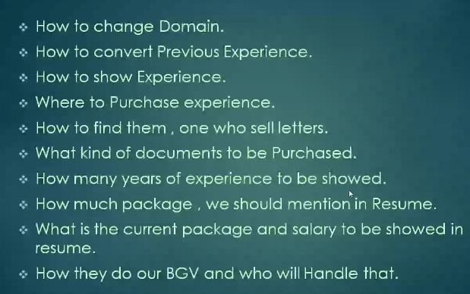

**KNOWLEDGE ON DOMAIN**

**DOMAIN NOTHING BUT PARTICULAR BUSINESS FIELD AREA OF EXPERTISE.**

**TYPES OF DOMAIN**

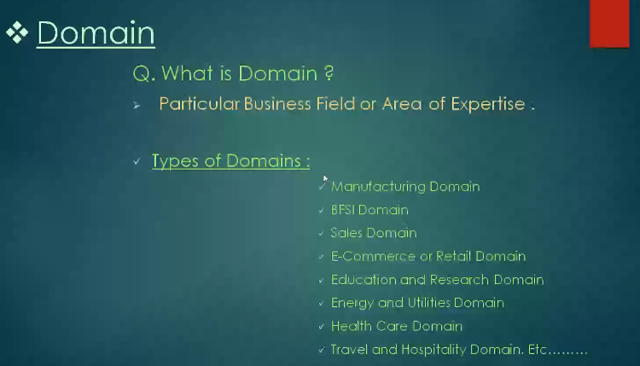

**BFSI DOMAIN BANKING FINANCE SECURITY INSUARANCE BUSINESSES**

**SALES**

**ECOMMERCE OR RETAIL = ANY APPLICATION WHICH IS USED TO BUY AND SELL THINGS ONLINE IS KNOWN AS ECOMMERCE AND RETAIL DOMAIN**

**EDUCATION AND RESEARCH DOMAIN = LIBRARY MANAGEMENT SW**

**UNIVERSITY SW**

**COLLEGE SW**

**ONLINE CLASSES SW**

**ENERGY AND UTILITIES DOMAIN = POWERPLANT BUSINESSES**

**HEALTHCARE DOMAIN= HOSPITAL , HOW MANY TYPE WE TREAT PATIENT ALL OVER THE GLOBE**

**TRAVEL AND HOSPITALITY DOMAIN= GOIBIBO , MAKEMYTRIP, OYO ETC.**

**FIRST PROJECT INTRODUCTION**

**CRM**

**CUSTOMER RELATIONSHIP MANAGEMENT**

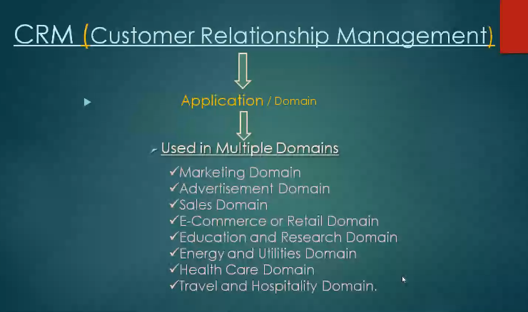

**CRM IS A ONE TYPE OF APPLICATION , USED IN MULTIPLE DOMAINS.**

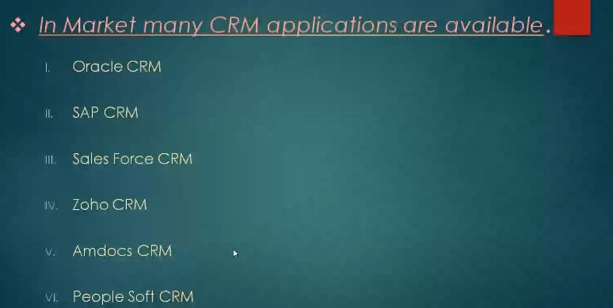

**ALL THREE SIZES OF CRM ARE AVAILABLE**

**SMALL SIZE**

**MEDIUM SIZE**

**LARGE SIZE**

**BUT EARLIER CRM APPLICATION USED TO BE VERY LARGE SIZE SO ONLY LARGE ORGANISATION WERE USING IT .**

**OUT OF ALL THESE WE ARE LEARNING ANY ONE OF IT .**

**ZOHO CRM**

**SHOWING EXPERIENCE**

**SIZE OF APPLICATION**

**AND**

**HOW WELL U CAN SPEAK ABOUT THAT PROJECT IN AN INTERVIEW (CONFIDENTLY)**

**ONE AND A HALF YEAR TO TWO YEAR**

**#JUST COPY SIR #**

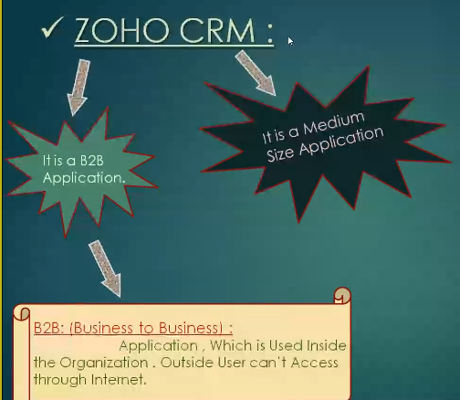

* **TO MANAGE CUSTOMER DETAILS IN AN ORGANISED WAY**

**ZOHO CRM USED IN WHAT KIND OF BUSINESSESS?**

**THOSE BUSINESS WHICH ARE TOTALLY DEPENDENT ON CUSTOMER RELATIONSHIP.**

**IF THEY DON’T HAVE NICE RELATION , THEY CAN’T RUN THEIR BUSINESS**

**FOR EXAMPLE = MEDICAL SHOP**

**ASSUME THAT I WENT TO PURCHASE SYRUP**

**I ASK THE PRICE**

**HE SAID 600**

**I WILL FIGHT WITH HIM**

**IF U WANT U PURCHASE OR MOVE FORWARD**

**I WILL ALSO MOVE FORWARD**

**THIS BUSINESS HAS NOTHING TO DO WITH CRM**

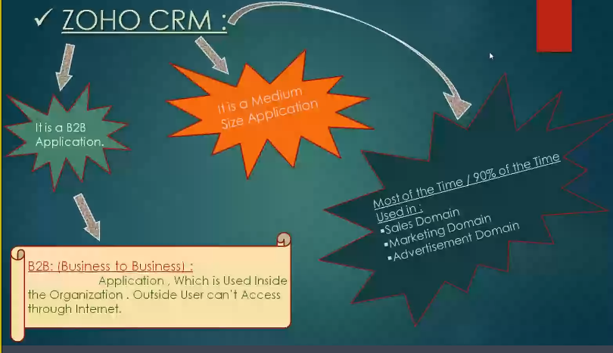

**IN SALES BUSINESS,**

**IN ADVERTISEMENT BUSINESS, U MUST HAVE ATLEAST PHONE NUMBER , EMAIL OR SOMETHING .**

**IN MARKETTING BUSINESS ALSO , ONE TIME THEY WILL COLLECT DATA AND WHOLE LIFE THEY WILL TEXT OR GIVE ADVERTISEMENT WHEREVER U ARE ON EARTH**

**SALES , MARKETTING AND ADVERTISEMENT DOMAIN**

**DOMAIN EXPLAINATION WILL BE DISCUSSED TOMMOROW.**